PROJ 201 Project Final Report

Cryptocurrencies and Stablecoins

Eşref Yılmaz 26575

Mustafa Erdem Adıgüzel 26610

Yalçın Öztürk 26657

Supervised by Kamer Kaya

15.01.2021

**ABSTRACT**

The developing growth of the internet in the 20th century and its place in our lives is gradually increasing. With this developing internet, new concepts started to be included in the world. In this respect, cryptocurrency is one of the new concepts of the internet which most known types are Bitcoin and BlockChain and various altcoins. In basic terms, cryptocurrency is considering a financial based blockchain which shares files or other resources between machines connected through a network, rather than using a central server such as central banks or monetary authority. With the development of the cryptocurrency, new concepts have emerged in recent years. For instance, it is observed that the volatility in other words value of most classics and top coins in general, especially bitcoin, decreases or increases very rapidly. For this reason, the stable coins concept, which has many sub-types in order to provide confidence to the investor, has gained an important place in the cryptocurrency universe. In this study, we will focus on the top coins, stablecoins and difference of stablecoins from classics and top coins. Furthermore we will mention why they should or should not be preferred, their types, functions i.e. what kind of system they have.

**INTRODUCTION**

There have been many failure attempts to create a digital currency in the 1990s because of the many different reasons such as abusing the system, financial problems that companies faced and conflicts between employees of the companies and their bosses. All of these digital currencies were based on a Trusted Third Party in order to facilitate the transactions and with the Trusted Third Party’s failures, the digital currency attempted to create was seen as a failure. By the introduction of Bitcoin by Satoshi Nakamato and a group of anonymous programmers in early 2009, the system based on Trusted Third Parties began to change. After the idea of bitcoin started to take its place in the market, it became one of the most significant shining stars of the last decade. Increasing its value exponentially, bitcoin reached the level of 27.000 dollars in the last quarter of 2020, but its value did not remain constant and its value was constantly losing or increasing in value which caused a loss of confidence in active investors. Due to such reasons, new ideas have started to emerge such as stable coins. Despite the other cryptocurrencies, Stable coins are designed to minimize the change in prices of the stable coins which consist of 4 types: Commodity-backed such as Digix Gold Token(DGX) , Fiat-backed such as Tether (USDT), USD Coin (USDC) and Diem(DIEM) Cryptocurrency-backed such as Wrapped Bitcoin(WBTC) and Algorithmic-backed such as Reserve(RSV). In this project, we will clarify concepts of cryptocurrency, most significant top coins, concepts of stablecoins and additionally we will investigate and give information about popular stable coins. Additionally, we also indicate the connections with other cryptocurrencies.

**METHODS & MATERIALS**

In this project, we will first present general information about the concept of cryptocurrencies. Then, we will elaborate the most significant top coins which are the cornerstones of the concept of cryptocurrencies with graphs, charts, drawings, diagrams which we have obtained from various sources. Through these figures, we will clearly detail the values of top coins, their purpose, how much and why they are in demand. After this stage, we will examine the concept of stablecoins, which has recently become popular in the cryptocurrency world, with marketing data, value charts etc. Furthermore, we will focus on the purpose and status of the companies that release these stablecoins.

**RESULTS**

Introducing blockchain technology and altcoins, Bitcoin has come a long way since it came to the agenda and started a digital transform worldwide thanks to its features. However, besides Bitcoin, cryptocurrencies with a bright future have gradually started to prove themselves. Using it in bank transfers, being preferred as a payment infrastructure, using it as software in commercial life shows that it has progressed by expanding the scope of cryptocurrencies recently. In order to gain a better understanding of the cryptography world, some terms need to be known such as blockchain and DeFi (Decentralized Finance). The reason blockchains and DeFi are important to gain a better understanding of the subjects is unlike central banking systems, most of the cryptocurrencies use decentralized control systems like blockchains. Blockchains consist of many blocks which each one of which is linked to the previous block. In these blocks, there are numbers of transactions and with every new transaction, a record of this transaction is attached to each investment’s ledger. Thanks to this feature of the blockchains, the system is made very difficult to hack or change (“What is blockchain?,” n.d.). On the other hand, DeFi is inspired by blockchain technology for the purpose of not controlling the whole transactions’ history from a single source. By this way, DeFi enables to overcome the speed limit and sophisticated transactions while giving users more control over their money compared to the centralized systems (“What is Defi?,” 2020).

**Bitcoin (BTC)**

Bitcoin is a digital currency that was created after the housing market collapse in January 2009. It follows the ideas set out by the enigmatic and pseudonymous Satoshi Nakamoto in a whitepaper. The identity of the individual or individuals who built the program is still a mystery. As a pan-global means of exchange, Bitcoin has many features that set it apart from conventional currencies. Unlike government-issued currencies, Bitcoin provides the guarantee of lower transaction costs than conventional online payment systems and is regulated by a decentralized authority. In other words, the number of Bitcoins is not regulated by central banks or monetary authorities and this is the idea behind Bitcoin (“What is bitcoin?,” n.d.).

Mining is the addition of new blocks to the system by deciphering cryptographic passwords and it is a necessary system for the production of Bitcoin and the continuity and security of the blockchain system. The decryption depends on the capacity of the computer and the length of the password. The critical aspect of the addition of new blocks to Bitcoin’s blockchain is proof-of-work. Blocks in the Bitcoin blockchain are summoned by miners and any time a miner comes up with new winning proof of work, a new block is approved to the Bitcoin’s blockchain by the network. In order to win the proof-of-work, miners need to have very specialized and expensive computers (“What is proof-of-Work?,” 2020). That is constantly led to innovations that will bring more profits in this field due to the increasingly competitive environment.

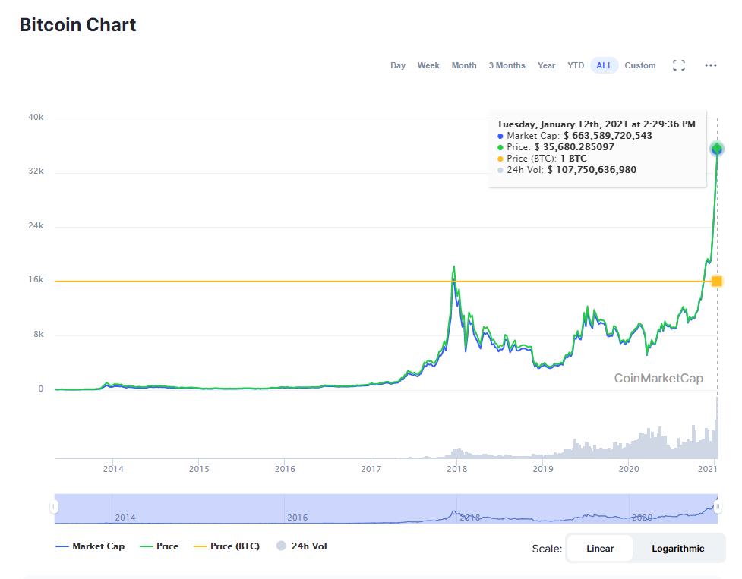

*Figure. Bitcoin Chart from Coinmarketcap*

Bitcoin has its own advantages and disadvantages. Among the advantages, Bitcoin has great potential for growth than other cryptocurrencies. As seen in the figure, Bitcoin has an enormously increasing market capacity and value over the last years. Also, Bitcoin enables people to do transactions securely and quickly with fewer potential fees. Since transactions do not require any personal information, it prevents any information related to the consumer is being stolen by other people and does not lead to possible identity thefts. On the other hand, Bitcoin has price volatility. Most people have second thoughts while entering the Bitcoin world since the price of Bitcoin was rising and falling very quickly as can be seen in the Bitcoin chart. Also, Bitcoin has hacking concerns. In terms of security, blockchain technology is seen as more secure than compare to the traditional ways according to backers; however, this does not mean that Bitcoin is completely secure. Hackers are always aiming to steal from Bitcoin wallets. For example, in May 2019, approximately $40 million worth of Bitcoins were stolen from several accounts by hackers (“What is bitcoin, and how does it work?,” 2021).

**Ethereum (ETH)**

Ethereum is a digital, open-source platform that runs and develops decentralized digital applications, or shortly “dapps”, using blockchain technology that allows people to perform transactions and make agreements directly with each other without any middle man to sell, buy and trade products and services. Voting systems, protection programs and methods of payment may be used in these applications (Rama-Poccia, 2018). Ethereum acts as a supercomputer through a global network of computers that work together. The network of Ethereum assembles and manages smart contracts - applications that are, independent of any censorship or intrusion from third parties, as the blockchain is immune to interfering with something in order to make unauthorized alterations. Smart contracts work exactly as planned, significantly minimizing the possibility of infringement, and are self-executing, such as a vending machine or an automaton that digitally executes the contract terms. Once such conditions, such as the transfer of a payment, are confirmed to have been fulfilled, then the goods are transmitted or made available to the buyer (Rama-Poccia, 2018).

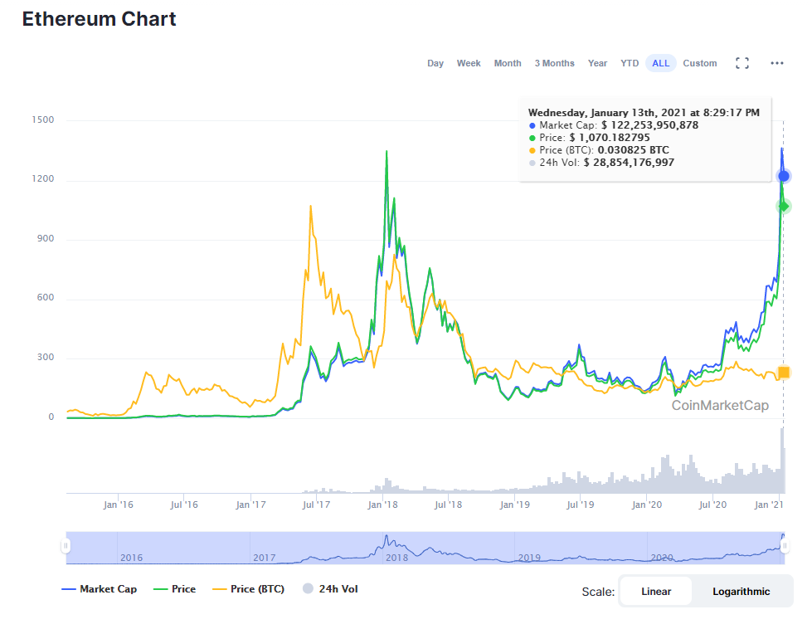

*Figure. Ethereum Chart from Coinmarketcap*

Ethereum’s smart contract is based on four basic technological building blocks which are peer-to-peer networking, cryptographic tokens and addresses, Turing complete virtual machine and consensus algorithms. Firstly, peer-to-peer networking is connecting people’s computers together to form a network for exchanging data without the necessity of a central server. Secondly, cryptographic tokens and addresses are a system that enables assets to be built on the existing Ethereum’s blockchain. Thirdly, Turing complete virtual machine is a virtual machine that can be run on a later abstraction above its hardware. Any program can be run by a “Turing complete” system and is powerful enough to enforce any program specified in any similarly complete computational system. Finally, consensus algorithms are algorithms that allow people of the blockchain to reach an agreement on the current state of the blockchain (“What is Ethereum?, n.d.).

**Bitcoin Cash (BCH)**

Like Bitcoin, Bitcoin Cash, with its own blockchain, is a cryptocurrency. It operates just like a digital currency, and via Bitcoin Cash mining, new Bitcoin Cash is produced. At the end of 2016, it was established, making it much younger than Bitcoin. As the creators of Bitcoin decided to make some j-major improvements to Bitcoin, Bitcoin was forced to establish Bitcoin Cash. The Bitcoin community’s developers could not reach an agreement on any of the improvements they wanted to make. So, a small group of these developers forced Bitcoin, with a few changes, to build a new version of the same code. Some of the important differences between Bitcoin and Bitcoin Cash are transfer fees, time is taken for a transaction and the number of transactions per second. Bitcoin Cash has a lot fewer transaction times compared to Bitcoin and also it is capable of doing more transactions per second than Bitcoin with cheaper transaction fees (M, 2020).

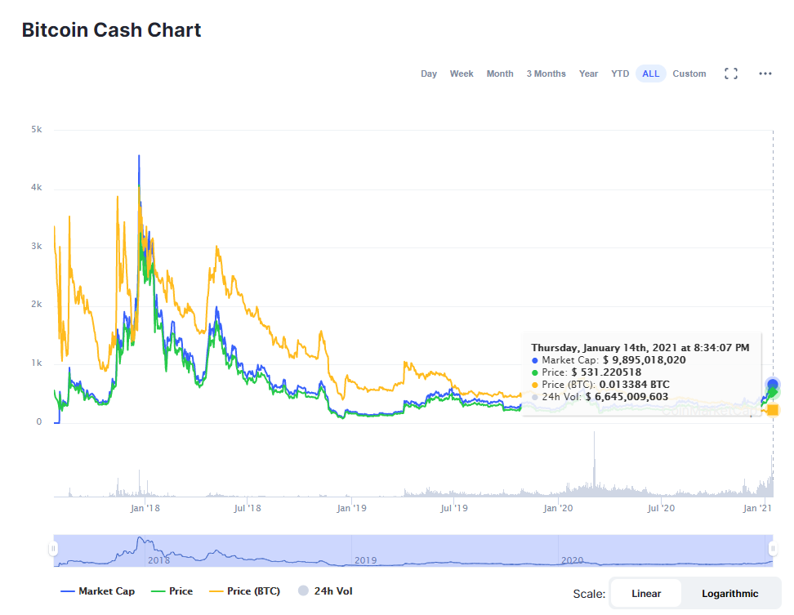

*Figure. Bitcoin Cash Chart from Coinmarketcap*

**BSV**

BSV also known as Bitcoin SV is a branched version of BCH, known as Bitcoin Cash. It was created at the request of the leading mining organization CoinGeek and other miners. This formation aims to provide a clear option for miners to implement BCH, and businesses to build apps and websites on it in a reliable manner. Initially, Bitcoin could do more than manage the processing load of a small niche community of developers and cryptography enthusiasts. However, with the increasing popularity of Bitcoin over time, the transaction volume also increased and blockages started. A serious problem started to occur over processing times. There was concern that Bitcoin transactions would take days or even weeks to clear. If these transactions took such a long time, transaction fees could increase significantly. These delayed wage concerns were at the heart of the problem. Bitcoin Cash aka BCH was the first Bitcoin fork to try to solve this problem. BCH was created to increase and expand transactions per second. With BCH, more data in each block means transactions can be processed faster. Also, the developers of Bitcoin Cash took measures to reduce the total amount of data requiring verification on each transaction, which made the process even faster. By comparison, the Bitcoin network can currently process 7 transactions per second, while Bitcoin Cash is processing about 116 transactions per second on average (Cryptopedia Staff, 2021).

Proponents of BSV, in principle, considered the Bitcoin protocol to be flawed and thought it unreasonable to rely on Bitcoin's structural approach. BSV advocates and developers claimed that the solution to this scalability-focused problem in Satoshi's original Bitcoin project was to increase block sizes. They started this project by increasing the block size from 1MB to 32MB (Cryptopedia Staff, 2021).

BSV is the native cryptocurrency of the Bitcoin SV blockchain. This currency works according to BTC's rules, with improvements to the block size. BSV was launched on November 15, 2018 for two main reasons: the notion that Bitcoin Cash implements and that its required features are not important enough to meet Bitcoin's requirements, and the desire to revert the Bitcoin protocol to the original Bitcoin design (Cryptopedia Staff, 2021).

The Bitcoin SV protocol was initially launched with a block size of 128 MB. With an update in July 2019, the block size was increased to 2GB. This protocol allows the selection of specified adjustable block sizes. So, miners can choose what size blocks they want to mine. The structure of BSV is based on processing more transactions at the same time (Cryptopedia Staff, 2021).

Bitcoin SV developers have announced that they have reached their highest capacity, reporting that they have processed an average of 300 transactions per second as of July 2020. These developers claim that Gigabit Testnet (GBTN) is capable of processing 5500 transactions per second due to its unlimited size. Even this claim shows that BCH and BTC are well above the transaction speeds. Although BTS aims to have a stable protocol structure to ensure and maintain the stability that investors and traders seek, its future is still a matter of curiosity. Big blocks are faster, but fewer nodes can follow larger blocks. Smaller blocks are slower, but retain the key benefits of security, and more nodes can join and maintain the network (Cryptopedia Staff, 2021).

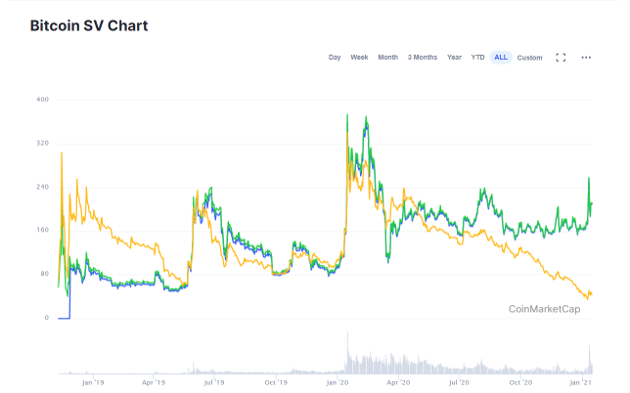

*Figure. Bitcoin SV Chart from Coinmarketcap*

**LTC**

Litecoin is a peer-to-peer cryptocurrency launched under the MIT / X11 license and is also an open source software project. Litecoin was released via an open source client on October 7, 2011 by Charlie Lee, director of engineering at Google and the Litecoin network went live on October 13, 2011. Unlike Bitcoin, Litecoin aims to process Bitcoin's 10 minutes versus its 2.5-minute block. This means that it verifies much faster than Bitcoin. Unlike Bitcoin, Litecoin uses SCRYPT, which is a sequential memory function that requires more memory in memory than an easy algorithm. Litecoin, like all other cryptocurrencies, is not mined by the government. Instead, it comes out of a press at the Bureau of Engraving and Printing, overseen by a Federal Reserve, and a detailed procedure called litecoins mining has been established. The existing block in Litecoin is verified by the mining software and made visible by any miner who chooses it. When verified by the miner who chose this block, the next block enters the chain, which is a record of every Litecoin transaction ever made. This is how Litecoin works (McFarlane, 2019).

There is also a reward system for encouraging mining. Miners who successfully verify a block will be rewarded with 50 Litecoins. With this reward and incentive system, defrauding the system must happen by making the miners fake the transaction, and this is almost impossible (McFarlane, 2019).

There are a limited number of coins in both Bitcoin and Litecoin. But one of the advantages of Litcoin over Bitcoin is that it has more coins. While Bitcoin has 21 million coins, Litecoin has 84 million coins. In addition, Litecoin is one of the most traded cryptocurrencies, although it has a smaller currency value than Bitcoin.

As for Litecoin, when you buy Litecoin on any exchange, its price is obtained in the US. So buy from the USA to get Litecoin. When the value of Litecoin rises, it is sold for profit because it is now worth more USD than its purchased value. There were several factors affecting Litecoin's price. The first of these is the state of regulation. Since the cryptocurrency is not currently regulated by governments and central banks, it is unknown what impact Litecoin will have on its value. The second is the supply situation. Since there are a limited number of Litecoins such as 84 million, fluctuations may occur depending on the rate of entry of coins into the market (CMC Markets, n.d).

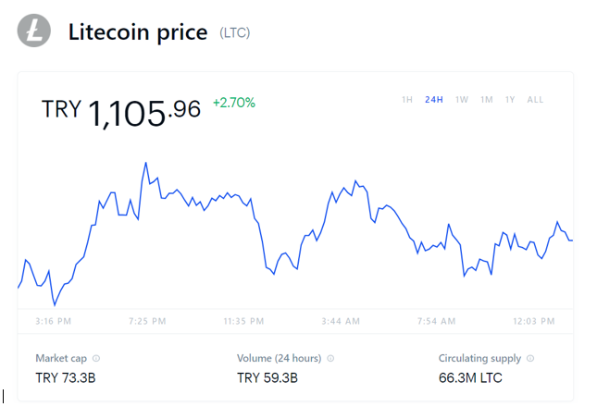

**XRP**

XRP, Ripple Inc. It is a currency partially managed by RippleNet that also manages the cross-border payment network. Unlike Bitcoin and Ethereum, Ripple does not focus on a blockchain network with a local cryptocurrency asset. The company has a history of testing XRP to adapt to the business world, first adopting it as a force giving solid support to cross-border payment technology and then turning it into a faster and cheaper international payment network such as xCurrent, xRapid and xVia (Harper,2020).

The main purpose of XRP is to intermediate fiat flow in other cryptocurrencies and exchanges, and the transaction cost in Ripple is $ 0.00001.

In addition to the RippleNet project, Ripple also oversees the XRP Ledger, a blockchain-like network launched by Ripple that facilitates payments in XRP, a digital currency. Like other currencies, XRP can be sent directly to a digital wallet, regardless of international borders. When Ripple launched XRP in 2012, it marketed it as a cheaper and faster alternative to Bitcoin. Because XRP's infrastructure is centralized, XRP can easily reach these speeds and the consensus algorithm used in Bitcoin for processing transactions is not used as proof of work (Harper,2020).

Unlike with Bitcoin, XRP coins are not mined. Ripple releases some of the demand from a particular warehouse intermittently and sells them on the open market. More than 45 billion are currently in network roaming. The structure and design of XRP compromises Bitcoin's decentralization. This network has a lower trust rate as Ripple breaks down Bitcoin's proof-of-work and consensus mechanism, but can also process faster than the same Bitcoin because the Validators' UNL is too central. This means that consensus can be understood and available faster and shared more quickly (Harper,2020).

One of the uses of XRP is currency exchange. Many currencies one cannot be directly converted into one another and banks use the United States as intermediaries. Ripple is used as an intermediary for this but is much cheaper than US dollars. Another usage purpose is international transaction. XRP's average processing time is 4 seconds. Based on these, one of the benefits is that it is much faster and cheaper than Bitcoin.

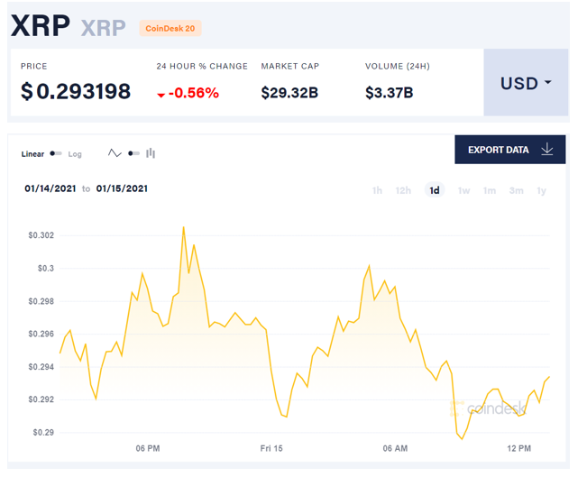

**BNB**

Binance Coin, which is short for BNB, is the currency created by Binance, one of the largest crypto currency exchanges in the world. Thanks to the size of Binance's transaction volume, BNB quickly gained momentum. BNB issued by Binance, one of the largest exchanges in the world, has good discount opportunities for Binance users. Binance Coin provides users with a 50% discount on transaction fees in the first year, 25% in the second year, 12.5% ​​in the third year and 6.75% in the fourth year. Of course, the main purpose of these discounts is to direct users to BNB use. Another opportunity for BNB Coin users is that it allows different options of Binance Coin varieties and various cryptocurrencies on the crypto currency exchange. However, there is no fiat currency trading. Additionally, it accepts Binance Coin for all transactions such as withdrawals for coin transaction transactions on the Binance platform. In addition, Binance has its own ICO editing platform (Coıntral, n.d).

Binance Coin is preferred especially in the BNB stock market because it provides a lot of opportunity and advantage. You pay a lower transaction fee for every transaction you make on Binance compared to other exchanges. For example, when you make a transaction on an exchange, if you do not have BNB Coin, a certain transaction fee is required. However, if you have a Binance Coin in your account when you make the transaction, your Binance Coin, which is half the transaction fee, is used for the transaction. Another reason why BNB Coin is preferred is that when the user invests in BNB Coin instead of other alternative sub-cryptocurrencies, the developments in the Exchange are reflected positively in Binance Coin and its value increases (Coıntral, n.d).

When Binance Coin first entered the market, the number of tokens was determined as 200 million. Half of those 200 million tokens were sold on the Binance ICO. 40% of these tokens are also sold to the Binance team. 10% of it was sold to angel investors. Many investors such as Roger Ver, one of the famous investors, have bought large amounts of Binance Coins (Coıntral, n.d).

With these situations, BNB has a wide range of uses to pay for travel expenses, buy virtual gifts, and more. BNB is also very helpful to its users in transaction fees. Normally, a standard transaction fee of 0.1% is charged for your transaction on the Binance Exchange. Transaction teaching can be paid in any other way that has been traded or by BNB. If you pay these fees for trading with BNB, there is a special discount on transaction fees at the exchange.(Binance Academy, n.d).

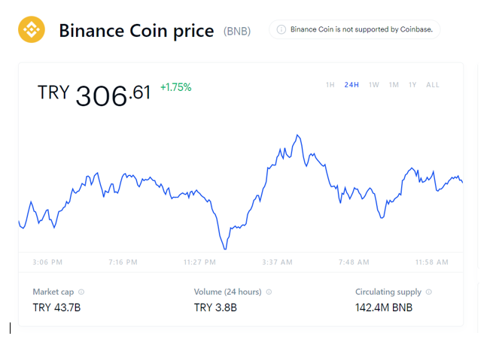

**Stable coins**

As mentioned earlier, cryptocurrencies, especially bitcoin, are highly volatile units. In other words, cryptocurrencies suffer from a lot of ups and downs. Due to these frightening movements in the market, various solutions have been sought for this problem in the cryptography world, and as a result, the significance of stablecoins and their demand in the market is increasing. The major difference of stablecoins from traditional crypto coins is that they have been supported by another currency, therefore stablecoins can be called crypto coins that are pegged to another currency (gold, dollar, etc.). The institution which creates the stablecoins, supports the total amount of money in circulation with the asset held in reserve. For example, if there is an amount of "x" in circulation, this amount of "x" is kept in the reserve (Ergin , 2018).

There are 4 different types of stablecoins which are fiat-backed, commodity-backed, cryptocurrency-backed and algorithmic. Despite fiat-backed and commodity-backed are centralized, cryptocurrency-backed and algorithmic have decentralized structure. In the fiat-backed structure, stablecoins are pegged to conventional coins such as USD, EUR etc. Stablecoins use this structure in order to fix their values ​​with these currencies at a ratio almost one to one. In the commodity-backed struct, it is collateralized to gold, but they can be collateralized to other commodities too. For instance metals, oil, or real estate. On the other hand, in the Cryptocurrency-backed category, which has a decentralized structure, stablecoins are pegged to cryptocurrencies. In this case, stable coins fixed to any cryptocurrency usually keep the amount in reserve at the rate of 1: 2 to prevent volatility in the price. In the Algorithmic category, which has another decentralized structure, the supply of these stablecoins is controlled by an algorithm-based model known as seigniorage shares (CBINSIGHTS , 2020).

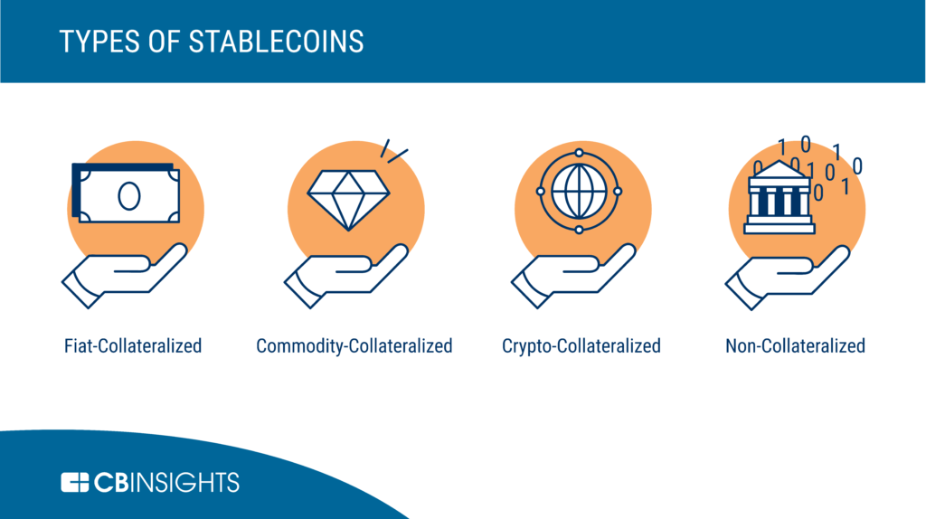

*Figure. Types of Stablecoins from CBINSIGHTS*

Stablecoins have several advantages and disadvantages. Stablecoins protect users from high volatility, provide fast and low-cost transactions, the famous banks have recently entered this business in central stable coins and also the lack of the center of algorithmic-backed stablecoins and it gives confidence due to their transparency are accepted the main advantages of stable coins. On the other hand, stablecoins have relatively slow transaction speed in the commodity-backed system, especially if stablecoins are pegged to real estate. Furthermore, the working mechanisms of cryptocurrency-backed stablecoins are complex and not gaining much popularity yet, and the balance of supply and demand in algorithmic stablecoins can be disrupted. In this respect, whether stable coins are investment tools or not is a dilemma that has been discussed recently. Investing in fiat-backed stablecoins can be a useful option for investors looking for an opportunity to invest in a volatile asset such as Bitcoin. They can be quickly and easily converted once the trust of the volatility of the asset is restored. As it is known, stablecoins can form a valuable part of a diversified investment portfolio, as they are generally regarded as low risk. In particular, over time, assets can increase in value and become profitable long-term investment such as commodity-backed or cryptocurrency-backed stable coins. On the other hand, despite these advantages, there are various factors that prevent stable coins from becoming an investment tool. One of them could be a risk for Cryptocurrency-backed stable coins, despite existing mechanisms to deal with inevitable price volatility. Also, fiat-backed stablecoins are considered to be the most stable of stablecoins, but this stability does not make them a very profitable long-term investment and their value is unlikely to increase significantly over time (O’neill , 2020).

**Tether (USDT)**

Tether, shortly USDT, is blockchain based cryptocurrency whose value is fixed at 1 US dollar by Tether Limited in 2014. When Tether came out in 2014, the coin came out with the name RealCoin, then due to the configurations in 2015, it changed its name to Tether. In 2015, Tether was firstly launched on the Omni layers protocol which is built on Bitcoin’s blockchain. However, due to the reasons of increasing market capacity over years and not satisfying the requirements of Tether Limited Company in terms of network transaction fees and transaction times, Tether Limited decided to also use ERC-20 blockchains which is an Ethereum token standard for integrating tokens for use as cryptocurrencies in smart contracts, and TRX blockchains which are the blockchain of Tron (“What is Tether?,” n.d.).

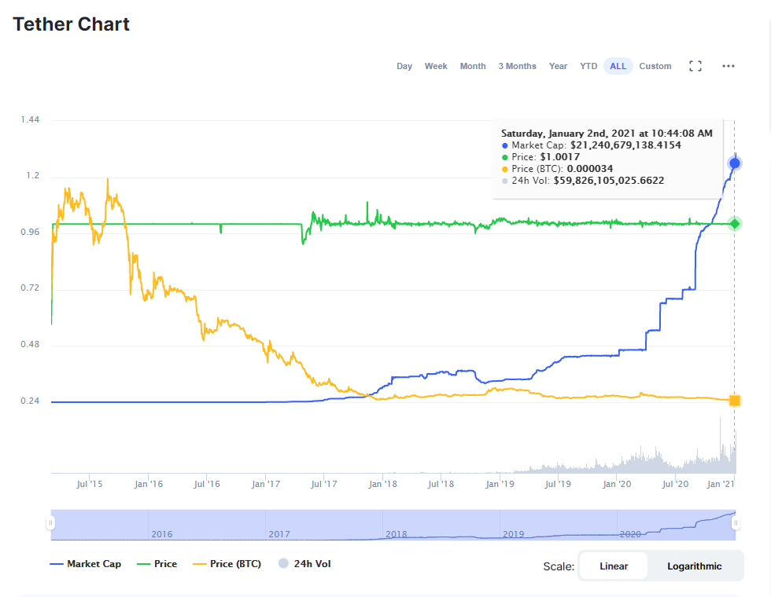

*Figure. Tether Chart from Coinmarketcap*

Tether cannot be mined as other types of cryptocurrencies. The main reason for this is that Tether Limited claims that the company has reserves of the equivalent of 1 US dollar for each Tether on the market. However, this argument has been widely controversial over the years. Skeptics argue that the company did not provide any evidence to prove this for many years and that its accounts were not audited. Although Tether Limited publishes the full audit report started as of September 2018, a digital currency expert lawyer in New York Times stated that the document was not written in a way to prove that Tether coins were backed by US dollars at that time (“Gizemli kripto para tether nedir?,” 2018). Moreover, in 2019, Tether Limited Company was accused of closing Bitfinex’s $ 850 million customer fund loss with its reserves and covered up this incident. The case is still ongoing. By considering all of these, it can be said that Tether has a very turbulent past.

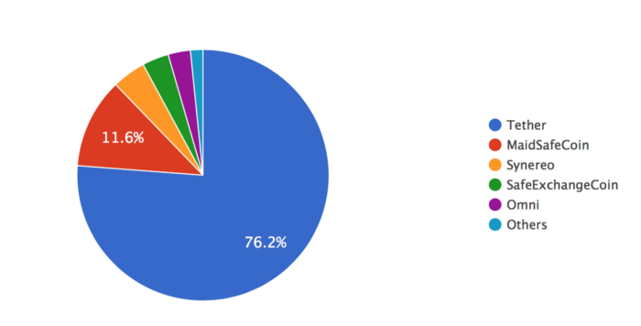

*Figure. Omni’s Transaction from Medium.com*

Despite such a turbulent past, Tether has been seen as the electronic version of the US dollar these days. Due to the conveniences they provide to investors, Tether’s market capacity is increasing day by day as can be seen in figures. Tether provides investors to avoid volatility and fees while investors remain in the crypto market. Tether can also be transferred without paying extra transaction fees and that’s why 75 percent of Omni’s transactions ever were done by Tether as can be seen in figure 2 (“What is tether?,” 2020).

**Diem / Libra**

Diem or formally known as Libra, is an upcoming currency or cryptocurrency in 2021 proposed by Facebook Inc. The people who are in charge of Diem are called the “Libra Association” and their aim is functioning Diem as a stable coin pegged to euro or dollar. According to white paper of Diem, Diem will run on its own blockchain; however, on that point there is a significant difference from other cryptocurrencies. The difference is unlike on other crypto currencies Diem’s nods cannot be run from other servers except association members of Libra. The idea behind is to increase the number of transactions per second and at the same time shorting the processing times. So that is why there are disagreements about Diem being a cryptocurrency (Volpicelli, 2019). Diem aims to become a new global currency that can be used in buying stuff or easily transferred from somewhere to another in a very short amount of time. One of the most important things about Diem is being able to contribute even to people who do not have access to any financial services or banks. Because of that reason Diem is seen as a competitor of most of the banks. It is claimed that Diem can do most of the operations that banks can do with more quickly and more efficiently so that reason it seems possible that Diem has great potential in the future world.

**Wrapped Bitcoin (WBTC)**

Wrapped Bitcoin (WBTC) is a variant of stablecoins which uses the Cryptocurrency-backed structure. Wrapped BTC was created in January 2019 as a collaboration project between major organizations such as BitGo, Ren, Dharma, Kyber, Compound, MakerDAO and Set Protocol. The project is now controlled by the Decentralized Autonomous Organization (DAO), which is called WBTC DAO. WBTC is pegged to bitcoin at a ratio of 1: 1. One of the most important features of WBTC is that it is an Ethereum-based token with ERC20 standard. Therefore, WBTC allows Bitcoin holders to use applications on the Ethereum network. In this way, Bitcoin users can make transactions in the DeFi world without selling their Bitcoin (Özer , 2020).

*Figures. Value of WBTC from binance.com*

The production process of Wrapped Bitcoin (WBTC) includes several steps. The executive members of the WBTC DAO decide who can assume the roles of those who run the system and the Custodians, as well as major upgrades and changes to the protocol. Users who own BTC and want to convert it to WBTC should interact with Merchants. Vendors initiate the printing or burning process of WBTC tokens by implementing verification procedures to authenticate users. Custodians hold the real BTC wrapped and do the actual printing and burning of the tokens on the Ethereum blockchain. When the WBTC is burned, the BTC is returned to the user from the Custodian's custody. When the new WBTC is pressed, the BTC is retrieved from the user and stored by the custodian (Tran , 2020).

On the other hand, Wrapped Bitcoin (WBTC), which provides its users with the above advantages, is increasing its volume every day. 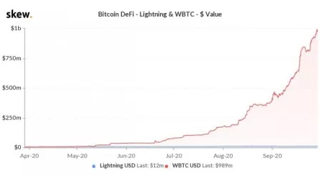

*Figure. Volume of WBTC from skew.com*

**USD Coin (USDC)**

USD Coin (USDC) is a stablecoin which uses the fiat-backed infrastructure and launched by Circle in 2018 and its value has been pegged to 1 USD. It is developed based on Ethereum and using the ERC-20 structure, USDC promises not to be affected by the unstable structure of cryptocurrencies. According to Circle CEO Jeremy Allaire, some of the key features of USDC are its low cost, which takes its speed from the internet, and it is a traditional currency on a global level that offers high security. Allaire pointed out these factors are a huge improvement for customers around the world who send and receive money, and businesses that accept their payments digitally (Ata, n.d.).

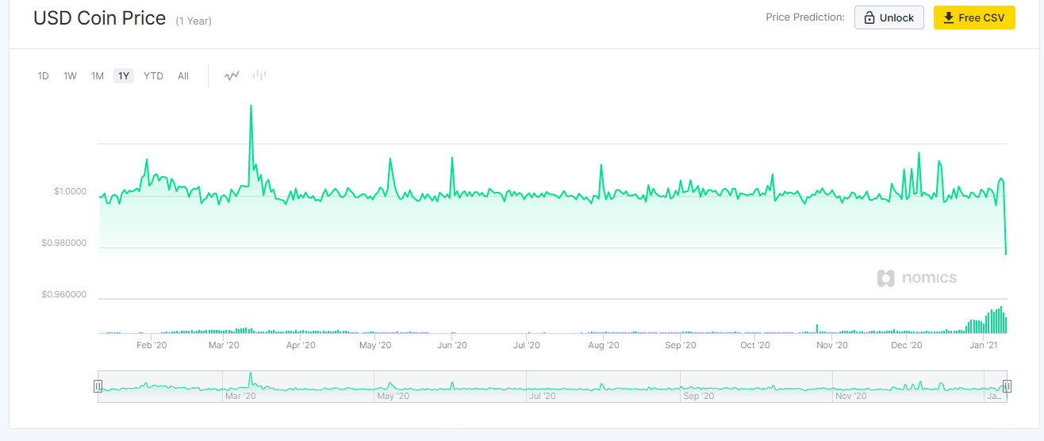

*Figure. Value of USDC from nomics.com*

In this respect, USDC is built on the ERC-20 standard, which can be considered to mean that the money transfer speed is as good as ETH has. Furthermore, users can deposit USD from their bank account, then convert the money into tokens, and then purchase and withdraw USDC tokens to a bank account. In other words, they can facilitate their transactions in the crypto world. However, USDC is a project with uncertain perspectives like other coins in the crypto world, and it is difficult to predict how it will continue in the coming years.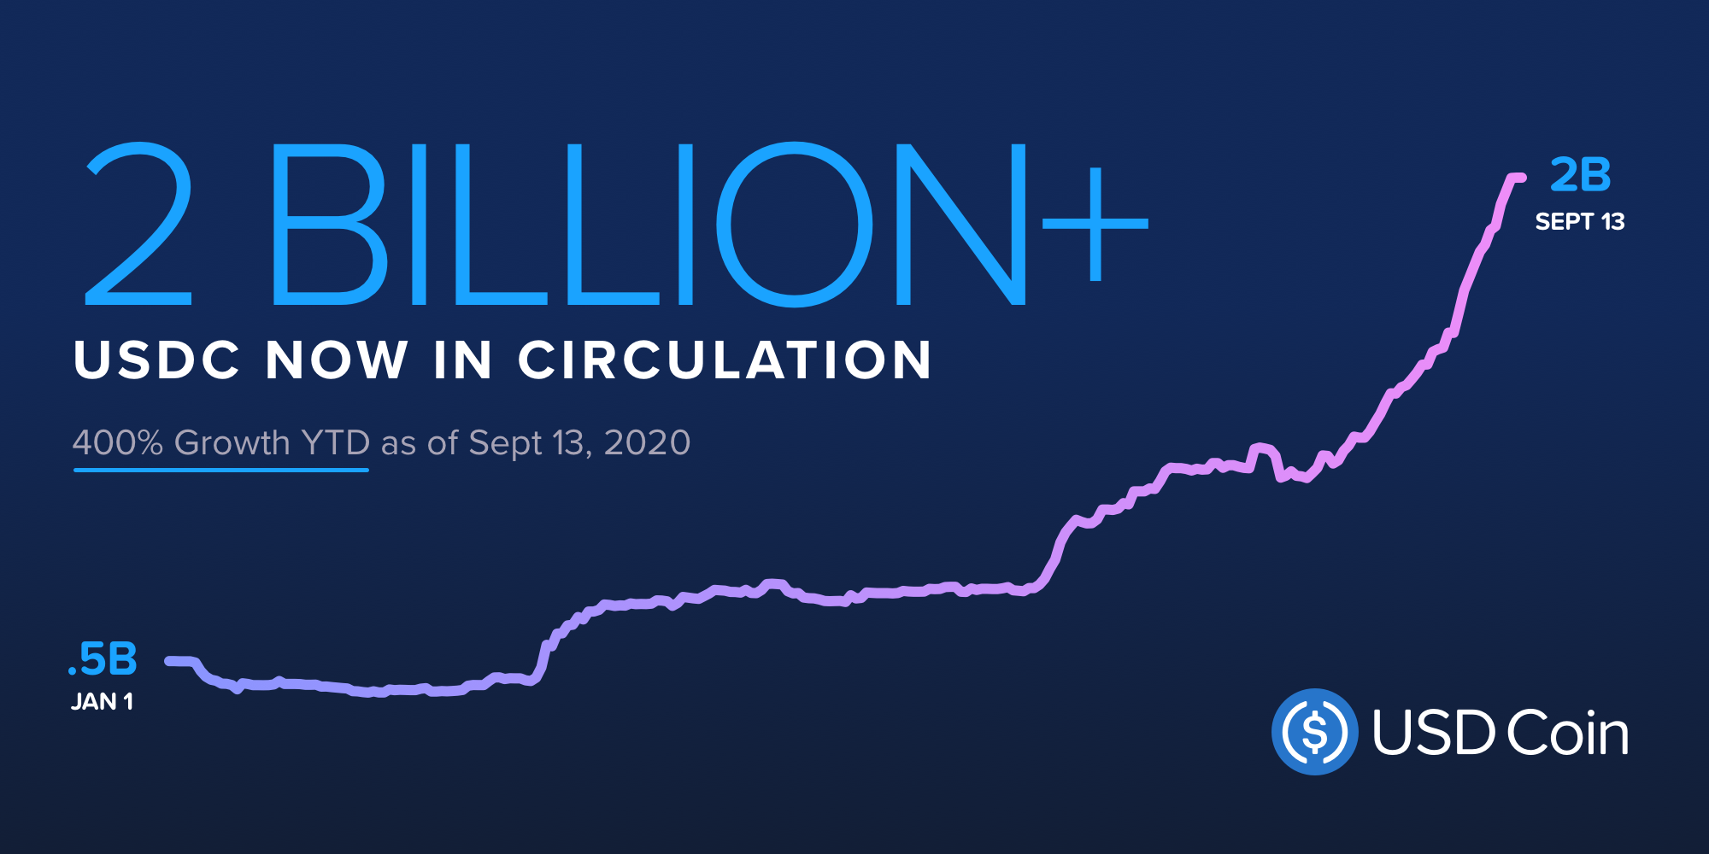

*Figure. Circulation Table of USD Coin from circle.com*

**DigixDAO Token(DGD) & Digix Gold Token (DGX)**

The DIGIX platform consists of two tokens, DGX and DGD. The base currency of this platform is DGX, which provides the gold access process. DGX will be created when someone wants to buy gold on the Digix gold market. In this way, investors will get DGX equivalent to gold purchased through Digix and will be able to use them for equivalent gold at any time. On the other hand, DGD functions as a kind of "management token" in the growth of the Digix platform of the self-organizing community. In other words, DGD is the governance token of DigixDAO. Holders of DGD tokens have voting rights and other management rights to decide how Digix's entire ecosystem should progress. DGD holders will be entitled to receive awards in the form of DGX from transaction fees and asset management fees received from gold investors in return for their work and contributions. In addition, on this platform, physical gold is represented by DGX tokens. 1 DGX corresponds to 1 gram of gold on the Ethereum Blockchain (Agrawal, 2019).

Features such as transparency, security and traceability provided by the blockchain allow DGX tokens to be traded and transferred in a fully visible and controlled manner. In addition to increasing the security of the impossible ledger, the smart contract platform eliminates the potential human error and fraud risk that can be seen in the gold supply chain (Agrawal, 2019).

This platform uses the PoA (Proof of Presence) model. This protocol transparently and securely tracks assets from the supplier to the safe. It does this with IPFS, which are both decentralized, persistent and fixed, and private keys and documents uploaded to the blockchain. This protocol generates PoA asset cards based on many processes. For instance, card creation timestamp, SKU of the gold bar from Digix Marketplace (Unique ID number of product), custody chain digital signatures (vendor, responsible, auditor), bar serial number, purchase receipt, audit documents, storage fee, warehouse receipt. Furthermore, PoA asset cards are stored in an Ethereum wallet. All these operations are done to generate the Proof of Asset card, which is eventually fed into the Digix Gold smart contract to generate DGX at a ratio of 1 gram: 1 DGX (Agrawal, 2019).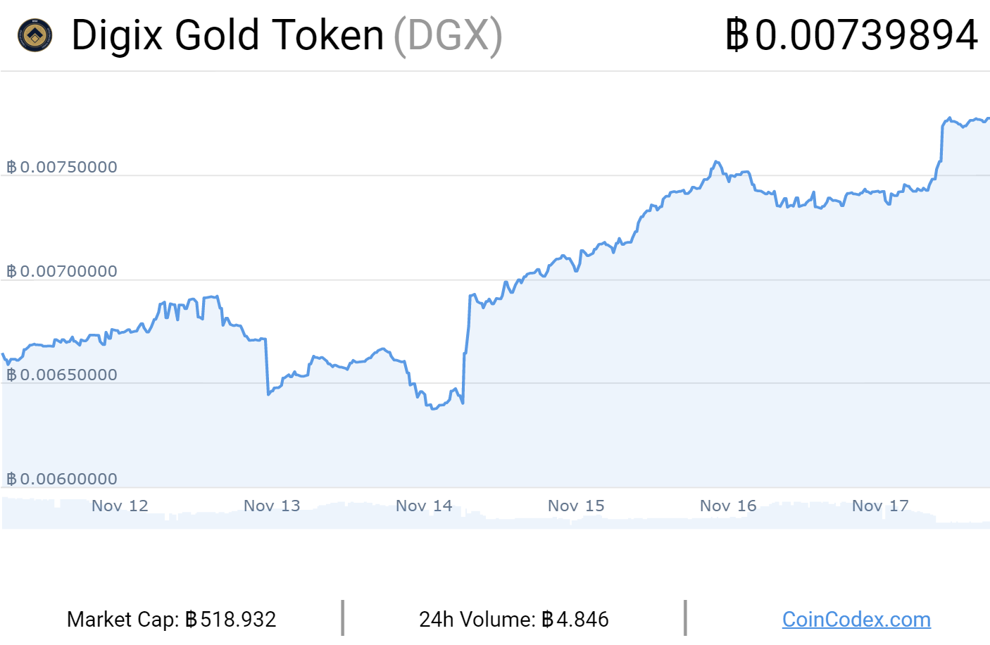

*Figure. Market cap of DGX coincodex.com from nomics.com*

**Reserve Rights Token (RSR & RSV)**

The Reserve protocol is an algorithm-based version of stablecoin. There are two types of tokens on the Reserve platform which are RSV and RSR. Reserve token (RSV) is a stable cryptocurrency with a scalable and legally strong infrastructure. Moreover, it is a decentralized, 100% asset-backed token financed by top investors in Silicon Valley. Reserve Rights token (RSR) is a token that uses the fluctuating protocol, which plays a role in balancing (stability) of RSV (Reserve, n.d.).

There are several main reasons why the Reserve team created this project. One of them is that in some parts of the world, currencies are losing value and governments are struggling to maintain a stable value in their currencies. Furthermore, according to the Reverse team, in the future dominant cryptocurrency will be a decentralized, dollar-independent stablecoin, changing the economic situation in many countries around the world (Yavuz , 2020).

The fact that this project fights inflation is of great interest. That's why this token also seems to be considered valuable. Although investors abstain from the reserve for now, this exciting project should be followed.

**DISCUSSION AND CONCLUSION**

In conclusion, cryptocurrency is necessary, and as some can speculate, it does not go away or be restricted to 100 years: transactions are easy, digital, safe and worldwide, which effectively enable records to be preserved without the risk of piracy of data. The importance of stable coins in this cryptocurrency world should not be underestimated. Stable coins act as a bridge between cryptocurrencies and should not be seen as investment tools due to their low volatilities and their low transaction fees. Because of these reasons, stable coins have a strong allure with more stable prices. Also, as a digital currency that can be used to make payments worldwide, Stable coins have the opportunity to support this large unbanked and underbanked community. Some of the stable coins can act as a digital version of the dollar or euro in the future world. With the help of those stable coins, the number of transactions made in one second and transaction times might change enormously compared to today’s world.

**REFERENCES**

Agrawal, H. (n.d.). *DigixDAO & Digix gold: A beginner's guide to tokenized gold*. CoinSutra - Bitcoin Community.<https://coinsutra.com/digixdao-digixgold-dgd-dgx>

Ata, E. (n.d.). *USD coin | Türkiye*. Kripto Para TR.<https://www.kriptoparatr.com/usd-coin>

CMC Markets, (n.d). *What is Litecoin, and How Does it Work ?* <https://www.investopedia.com/articles/investing/040515/what-litecoin-and-how-does-it-work.asp>

Coıntral, (n.d). *What is BNB Coin ?.* <https://cointral.com/what-is-bnb-coin/#:~:text=Binance%20Coin%2C%20abbreviated%20as%20BNB,the%20largest%20crypto%20currency%20exchanges.&text=In%20addition%2C%20Binance%20allows%20the,is%20no%20fiat%20currency%20trading>.

Ergin, Ö. (2018, October 19). *Stablecoin Nedir? Kullanım Amacı ve Farkları Neler?* Coinkolik.<https://www.coinkolik.com/stablecoin-nedir-kullanim-amaci-ve-farklari-neler/>

*Gizemli kripto para tether nedir?* (2018, February 1). BloombergHT.<https://www.bloomberght.com/kripto/haber/2092221-gizemli-kripto-para-tether-nedir-yatirimcilar-neden-endise-etmeli>

Cryptopedia Staff, (2021). *Bitcoin SV (BSV): A Bitcoin Fork to Realize Satoshi’s Alleged Vision.*

<https://www.gemini.com/cryptopedia/bsv-what-is-bitcoin-sv>

Harper, C. (2020, Dec 22). *What is XRP, and How Is It Related to Ripple ?.* <https://www.coindesk.com/what-is-ripple-what-is-xrp>

McFarlane, G. (2019, Jun 25). *What is Litecoin, and How Does It Work?.*

<https://www.investopedia.com/articles/investing/040515/what-litecoin-and-how-does-it-work.asp>

M, L. (2020, July 20). *Bitcoin cash vs bitcoin: Understanding the difference between them*. BitDegree.org Crypto Exchanges.

<https://www.bitdegree.org/crypto/tutorials/bitcoin-cash-vs-bitcoin#bitcoin-cash>

Neşe, Y. (2020, October 25). *Reserve rights (RSV) Nedir?* Coin Bilgi.<https://www.coinbilgi.net/reserve-rights-rsv-nedir/>

O'neill, R. (2020, September 4). *What are Stablecoins? Are They a Good Investment?* https://blog.bybit.com/learn/what-are-stablecoins-are-they-a-good-investment/.<https://blog.bybit.com/learn/what-are-stablecoins-are-they-a-good-investment/>

Rama-Poccia, M. (2018, December 4). *What is Ethereum and how does it work?* TheStreet.<https://www.thestreet.com/investing/what-is-ethereum-14797423>

*Reserve*. (n.d.). Reserve.<https://reserve.org/>

Tran, K. C. (2020, April 6). *What is WBTC?* Decrypt.<https://decrypt.co/resources/what-is-wbtc-explained-bitcoin-ethereum-defi>

Volpicelli, G. (2019, August 13). *What is Libra? Facebook's cryptocurrency, explained*. WIRED UK.<https://www.wired.co.uk/article/facebook-libra-cryptocurrency-explained>

*What are Stablecoins?* (2020, August 17). CB Insights Research.<https://www.cbinsights.com/research/report/what-are-stablecoins/>

*What is bitcoin, and how does it work?* (2021, January 11). NerdWallet.<https://www.nerdwallet.com/article/investing/what-is-bitcoin>

*What is blockchain?* (n.d.). Euromoney.<https://www.euromoney.com/learning/blockchain-explained/what-is-blockchain>

*What is DeFi?* (2020, December 17). CoinDesk.<https://www.coindesk.com/what-is-defi>

*What is Ethereum?* (n.d.). ConsenSys.<https://consensys.net/knowledge-base/about-ethereum-eth/>

*What is tether?* (2020, October 26). Securities.io.<https://www.securities.io/what-is-tether-a-look-at-the-worlds-most-popular-stablecoin/>

Özer, I. (2020, October 7). *Wrapped bitcoin (WBTC) Nedir? Yeni Başlayanlar için Temel Rehber*. Coin Bilgi.<https://www.coinbilgi.net/wrapped-bitcoin-wbtc-nedir-yeni-baslayanlar-icin-temel-rehber>